Product Category | SD Card Connector
Card Connection Method | Self-ejecting
Card Type | MicroSD card(TF card)
Connector Type | Card Socket
Maximum Body Height | -
Contact Material | -
Contact Plating | -
Operating Temperature Range | -
Soldering Temperature (Maximum) | -
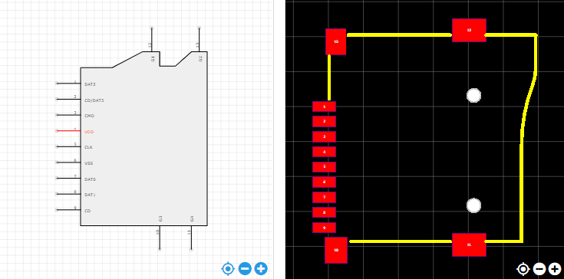
https://item.szlcsc.com/112422.html

